*FootyIntel AI*

**5.15 RESOURCE MANAGEMENT PLAN**

Revision 3

*12/6/2023*

**VERSION HISTORY**

| **Version #** | **Implemented**  **By** | **Revision**  **Date** | **Approved**  **By** | **Approval**  **Date** | **Reason** |
| --- | --- | --- | --- | --- | --- |
| 1.0 | *Eric Wnorowski* | *10/29/2023* |  |  | Initial Resource Management Plan draft |
| 2.0 | *Eric Wnorowski* | *11/12/2023* |  |  | Update accordingly with 5.24 Stakeholder Management Plan |
| 3.0 | *Eric Wnorowski* | *12/6/2023* |  |  | Final Revised Version |

**TABLE OF CONTENTS**

**1** **INTRODUCTION 3**

1.1 Purpose Of The resource Management Plan 3

**2** **RESOURCE MANAGEMENT PROCEDURE 3**

2.1 Process 3

2.2 Resource Identification 2

2.3 Data Representation 4

2.3.1 Organizational Theory 5

2.3.2 Meetings 5

2.4 Resource management plan outputs 5

2.5 Project Document Updates 2

**3** **TOOLS AND PRACTICES 2**

**APPENDIX A: REFERENCES 3**

**APPENDIX B: KEY TERMS 4**

# **INTRODUCTION**

## **PURPOSE OF THE RESOURCE MANAGEMENT PLAN**

Plan Resource Management is "the component of the project management plan that describes how project resources are acquired, allocated, monitored, and controlled" (PMBOK® Guide—7th Edition, Page 186). This plan defines how resources associated with the *FootyIntel AI* project will be identified, analyzed, and managed. It outlines how resource management activities will be performed, recorded, and monitored throughout the lifecycle of the project and provides templates and practices for recording and prioritizing risks. The Resource Management Plan is created by the project manager in the Planning Phase and is monitored and updated throughout the project. The intended audience of this document is the project team, project sponsor, management, and stakeholders.

# **RESOURCE MANAGEMENT PROCEDURE**

## **PROCES**S

The project manager working with the project team and project sponsors will ensure that resources are actively identified, analyzed, and managed throughout the life of the project. Risks will be identified as early as possible in the project so as to minimize their impact. The steps for accomplishing this are outlined in the following sections. The project manager will serve as the Risk Manager for this project.

## **RESOURCE IDENTIFICATION**

Resource identification will involve the project team, appropriate stakeholders, and will include an evaluation of environmental factors, organizational culture and the project management plan including the project scope. Careful attention will be given to the project deliverables, assumptions, constraints, WBS, cost/effort estimates, resource plan, and other key project documents.

Project documents that can be considered as inputs for this process include but are not limited to:

* Project schedule. The project schedule shows the timeline for needed resources.
* Requirements documentation. Requirements will dictate the type and amount of resources needed for the project and may influence how they are managed.
* Risk register. The risk register contains information on threats and opportunities that may impact resource planning.
* Stakeholder register. The stakeholder register aids in identifying those stakeholders who have a particular interest in or impact on resources needed for the project. It also helps to identify stakeholders who can influence the use of one kind of resource over another.
* Project Scope statement – describes the work that will be performed and the work that is excluded.
* Requirements documentation – describes how individual requirements meet the business need for the project.

The enterprise environmental factors that can influence the Plan Resources Management include but are not limited to:

* Organizational culture and structure
* Geographic distribution of facilities and resources
* Existing resources competencies and availability
* Marketplace conditions
* Enterprise environmental factors include football association regulations and laws that may affect the use of technology in football. The project will also need sufficient data to create the model, there should be sufficient access for this project.

The organizational process assets that can influence the Plan Resources Management include but are not limited to:

* Human resource policies and procedures
* Physical resource management policies and procedures
* Safety policies
* Security policies
* Policies, procedures, and templates for the WBS
* Project tools from previous AI projects done by the company
* Lessons learned from previous AI projects done by the company
* Software team to build infrastructure

Expertise should be considered from individuals or groups with knowledge of or experience with similar projects:

* The team will consult with data analytic experts currently in the football industry. These experts use data to provide insights in their specific team, which may provide context to the relevant data needed to create the project.
* Then utilize experts in data science and machine learning to find which models may be most effective for our project. Considering the project will utilize standard data in combination with video data it will be important to consult with experts in both fields to find which combination of models will be most effective.

Expert Judgment Obtained:

* The project team utilized the following resources to provide the described inputs in the development of the Plan Resource Management:
  + PMs of other AI teams in FootyAI – The Project managers of other artificial intelligence teams provided assistance in suggestions for the technology and methodology to be used on the project. Those with similar project goal provided insight into the various technologies that may be of use or make the team efficient/productive
  + Data Analysts (Premier League & MLS): Utilizing the companies previous relationships with football clubs the team used Data Analytics teams from both the MLS and Premier League to gain an understanding of the types of data being used, the conclusions drawn, and how they would use our product in their clubs.
  + Computer Vision Machine Learning Engineers: Subject Matter Experts that can provide detail on the model that would be most effective in our project scope. Computer Vision is specifically catered to image and video artificial intelligence.

Resource Needs Table:

| Cost/hr | Resource Type | Duration |
| --- | --- | --- |
| $ 50.00 | Project Manager | 12 months |
| $ 75.00 | Lead Data Scientist | 12 months |
| $ 70.00 | Data Engineer | 12 months |
| $ 60.00 | Machine Learning Engineer | 12 months |
| $ 60.00 | Machine Learning Engineer | 12 months |
| Will Vary | Cloud Storage | 6 months |
| Will Vary | Data Pipeline | 6 months |
| Will Vary | Model Training | 10 months |
| $ 20.00 | 3rd Party Data Labeling | 6 months |
| Will Vary | Production Software | 2 months |
| $40.00 | Software Team Assistance | 2 - 6 months |

## **DATA REPRESENTATION**

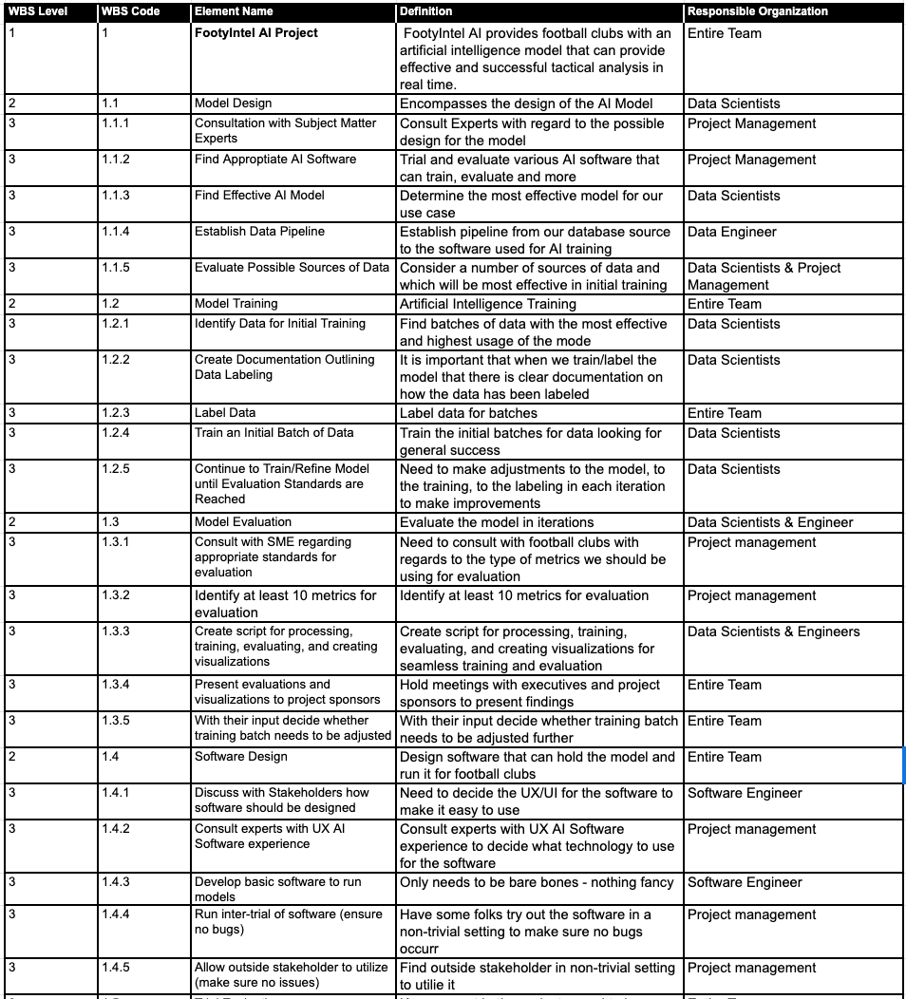

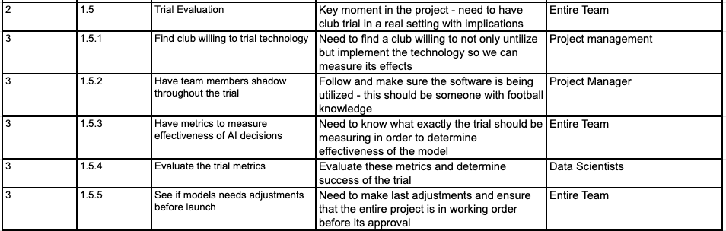

### **Organizational Theory**

FootyIntel AI Project will follow a projectized organizational structure led by the Project Manager and the Lead Data Scientist. The Machine Learning Engineers and Data Engineer will work together lead by the Data Scientist to create the technology and engineering behind the project. The Project Manager will oversee the overall project production and look to resolve any conflicts that the team may find during their work.

### **Meetings**

Everyday at 10AM the team will hold a stand up meeting where each team member will outline the work that they completed the previous day and any conflicts that they may have come across. Then they will check in with the Project Manager to ensure they know their work that is planned in the current iteration. Each Wednesday at 0900 we will have a standing 30 minute team meeting to review the planned schedule, discuss larger requirements and deliverables, or any other major talking point

## **RESOURCE MANAGEMENT PLAN OUTPUTS**

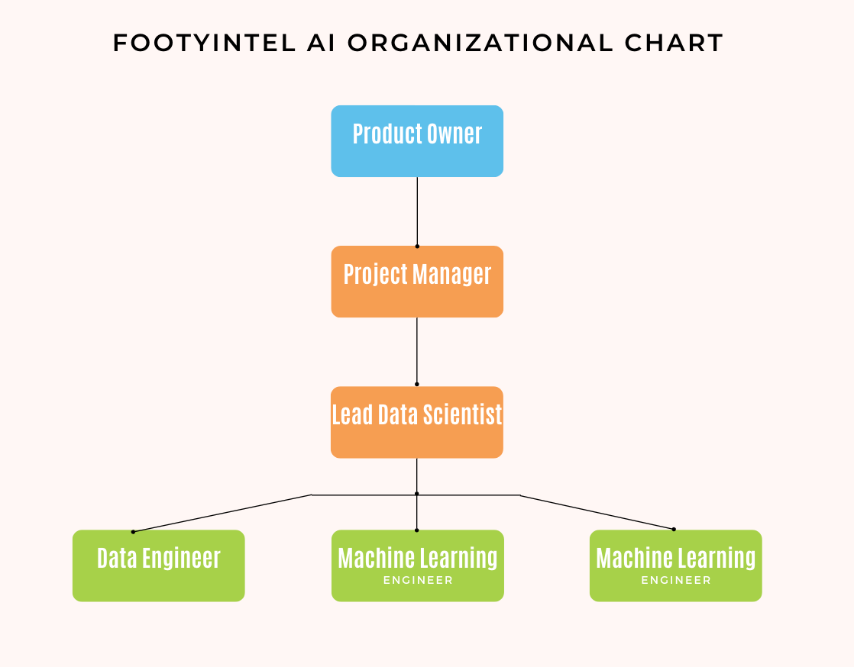

| RACI Chart | Person | | | | |
| --- | --- | --- | --- | --- | --- |
|  | PM | LDS | MLE | MLE | DE |
| Model Design | C | R | A | A | R |
| Model Training | I | R | R | R | I |
| Model Evaluation | A | R | A | A | A |
| Software Design | I | A | C | C | I |
| Trial Evaluation | R | I | X | X | I |
|  | R = Responsible A = Accountable C = Consult I = Inform | | | | |

| **Project Team Charter** | |
| --- | --- |
| **Team Values**  Respect for others, passion for quality, strive to deliver value    Awareness of planned work and willingness to communicate all aspects of work with team | **Communications Guidelines**  We will use face to face meetings during planning phases and during key deliverable updates. Daily Stand up meetings will take place virtually but mandatory is still expected |
| **Decision-making Criteria and Processes**  Each team member is empowered to identify issues requiring decisions and present them to the team for discussion. Recommendations will be provided to the PM and Lead Data Scientist whom have decision authority. | **Conflict Resolution Process**  Team members are encouraged to engage in discussion to work out conflicts at the lowest level possible before escalating for resolution. The project organization structure will be used to escalate all conflicts. The PM will work closely with company HR to resolve conflicts. |
| **Meeting Guidelines**  Team members are expected to attend all scheduled meetings. Meetings will have agendas published two days prior to allow members to prepare. Discuss with PM if you feel meeting attendance is unnecessary. | **Team Agreements**  All team members agree to abide by the Project Team Charter |

## **PROJECT DOCUMENT UPDATES**

Updates to Collect Requirements and Work Deliverable Documents have been made to be in stricter compliance with Resource Management ensuring that each work package and requirement is adequately assigned and managed.

# **TOOLS AND PRACTICES**

The Project Resource Requirements will be maintained by the project manager and will be reviewed as a standing agenda item for project team meetings.RESOURCE MANAGEMENT PLAN APPROVAL

The undersigned acknowledge they have reviewed the **Resource Management Plan** for the FootyIntel AIproject. Changes to this Resource Management Plan will be coordinated with and approved by the undersigned or their designated representatives.

| Signature: |  | Date: |  |
| --- | --- | --- | --- |
| Print Name: | Eric Wnorowski |  |  |
| Title: | AI Project Manager |  |  |
| Role: | Project Manager |  |  |

| Signature: |  | Date: |  |
| --- | --- | --- | --- |
| Print Name: |  |  |  |
| Title: | VP of Artificial Intelligence |  |  |
| Role: | Product Owner |  |  |

| Signature: |  | Date: |  |
| --- | --- | --- | --- |
| Print Name: |  |  |  |
| Title: | Chief Technology Officer |  |  |
| Role: | Product Owner |  |  |

| Signature: |  | Date: |  |
| --- | --- | --- | --- |
| Print Name: |  |  |  |
| Title: | Product Owner |  |  |
| Role: | Project Sponsor |  |  |

**APPENDIX A: REFERENCES**

The following table summarizes the documents referenced in this document.

| **Document Name and Version** | **Description** | **Location** |
| --- | --- | --- |
| 4.1 Project Charter Plan | Project charter is issued by the Chief Technology Officer & Vice President of Artificial Intelligence Software. The document is written to ensure a common understanding between the project sponsors, the product owner, the project manager, the project team, and the key company stakeholders. | Google Drive Key Documents Folder |
| 5.3 Collect Requirements Plan | This Collect Requirements Plan defines how requirements associated with the *FootyIntel AI* project will be identified, analyzed, and managed. It outlines how collect requirements activities will be performed, recorded, and monitored throughout the lifecycle of the project and provides templates and practices for recording and prioritizing requirements. | Google Drive Key Documents Folder |
| 5.5 Create WBS Plan | The WBS is a deliverable-oriented hierarchical decomposition of the work to be executed by the project team to accomplish the project objectives and create the required deliverables. It organizes and defines the total scope of the project. | Google Drive Key Documents Folder |
| 5.24 Stakeholder Engagement Plan | Stakeholder Engagement Plan is the process of developing approaches to involve project stakeholders based on their needs, expectations, interests, and potential impact on the project. The key benefit is that it provides an actionable plan to interact effectively with stakeholders. | Google Drive Key Documents Folder |

**APPENDIX B: KEY TERMS**

The following table provides definitions for terms relevant to the Risk Management Plan.

| **Term** | **Definition** |
| --- | --- |
|  |  |
|  |  |
|  |  |